GIT/ GITHUB:

[**Git**](https://www.simplilearn.com/tutorials/git-tutorial/git-tutorial-for-beginner)is a source code management. It is a free and open-source version control system used to handle small to very large projects efficiently. Git is used to tracking changes in the source code.

Features of Git

* Tracks history
* Free and open source
* Creates backups
* Scalable
* Supports collaboration
* Branching is easier

## **Git Workflow**

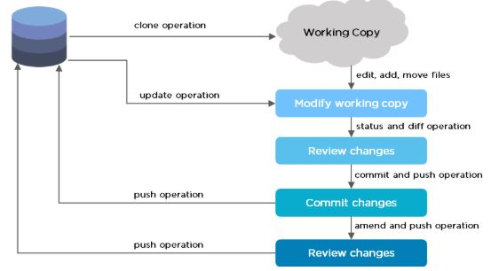

The Git workflow is divided into three states:

* Working directory - Modify files in your working directory
* Staging area (Index) - Stage the files and add snapshots of them to your staging area
* Git directory (Repository) - Perform a commit that stores the snapshots permanently to your Git directory. Checkout any existing version, make changes, stage them and commit.
* **GIT COMMANDS:**
* Check the version of Git.

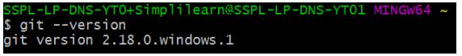

* Set up global config variables - If you are working with other developers, you need to know who is checking the code in and out, and to make the changes.

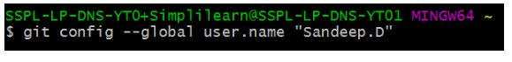

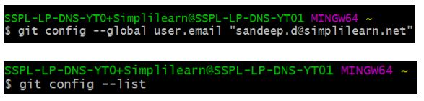

* **Create a branch “first_branch” and merge it to the main (master) branch.**

first-branch.

The below command switches to the new branch from the master branch.

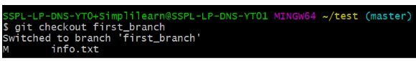

The above command creates and adds “info3.txt” to the first_branch.

info3text

* Create a branch “first_branch” and merge it with the main (master) branch.

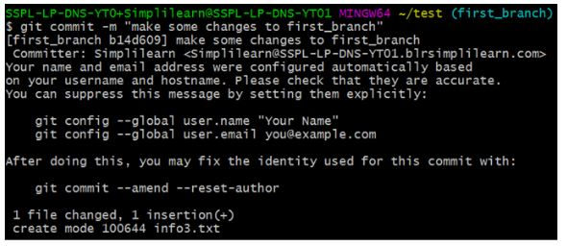

To check chstatus : git status

To add : git add . -m( ) to add all files

To add specific file: git add filename

To commit: git commit

To push the code into github: git push

To pull the code from master: git pull master

How to copy code /repository from master account: git clone url (copy the url of repository from master account .)

To pull the code from specific account: git pull useraname.

How to switch from master to specific account: git checkout reponame.

**GITHUB:**

It's used for storing, tracking, and collaborating on software projects.

It makes it easy for developers to share code files and collaborate with fellow developers on open-source projects.

1.How to clone the projects/repository from master branch to your local system

Ans: git clone url

2.How to create a new branch

Ans. Git branch new branch name

3.How to check the branches

Git branch

4.How to know that you are in which branch

Ans: First I’ll do git branch then it will display all the branches now where * is present that is the my present branch.

5.How to switch from one branch to other?

Ans: git checkout branch name

6.How to check your changes

Git status

7.How to push your changes

Ans:

* 1. Git add . – to push all the files

Git add filename - to push only specific file name

* 1. Git commit -m “comment …..”
  2. Git push

8.How to pull changes from main branch to your branch

Git pull origin branchname